**DOCKER DEEP DIVE**

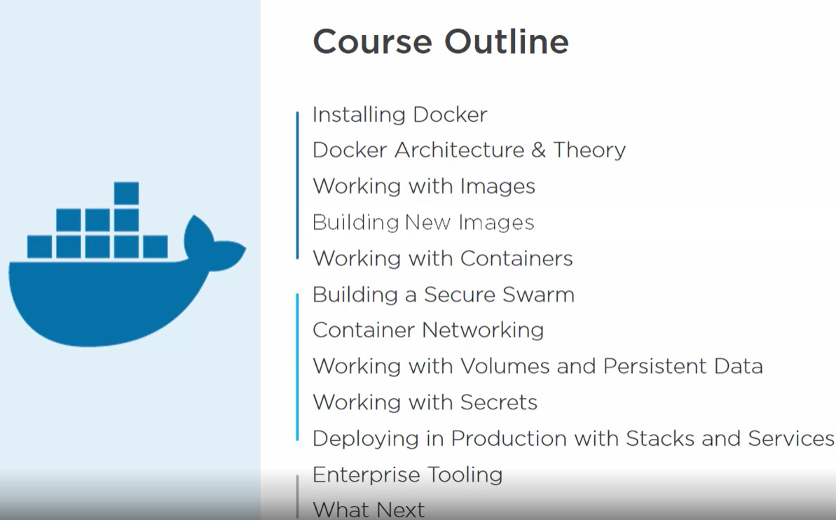

**Docker desktop has windows as well as Linux containers.**



To get enterprise edition of docker on windows.

**Architecture and Theory**



**Kernel stuff :**

Container is an isolated area of an OS with some limits of resource usage.

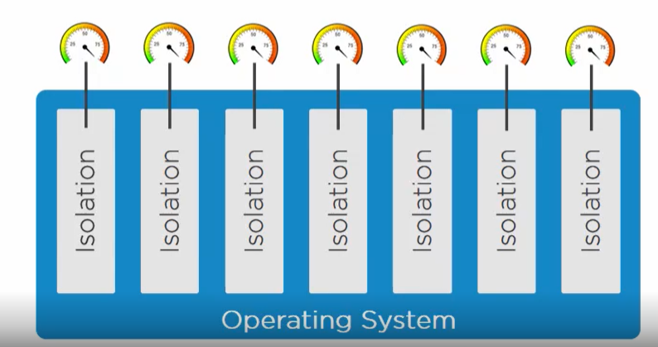

To build the container we need some low-level kernel stuff but they are very hard.

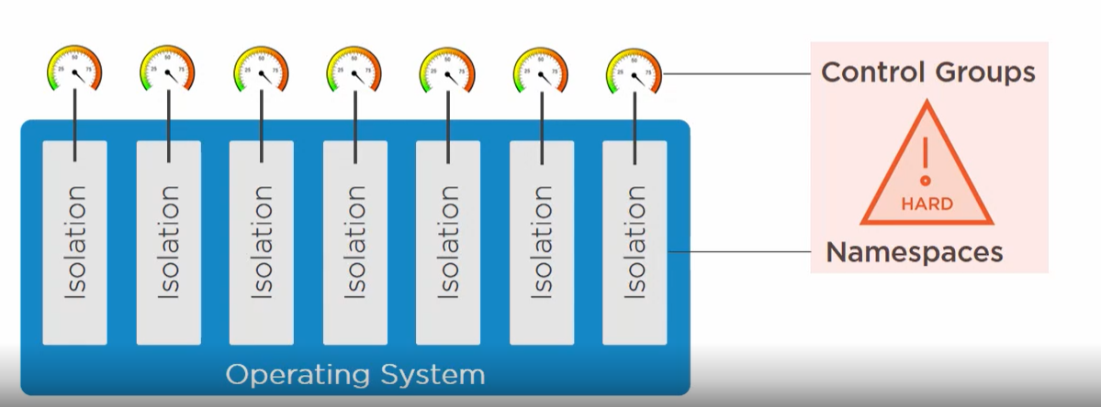

But docker engine makes it easy to create the container.

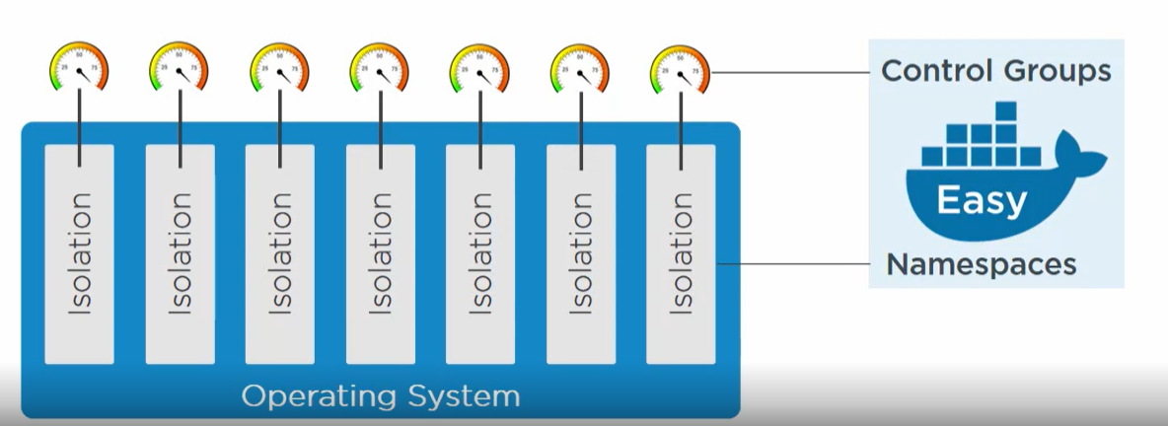

**Docker engine** is a modular engine with different modules there. We connect with docker engine using CLI and hit the APIs.

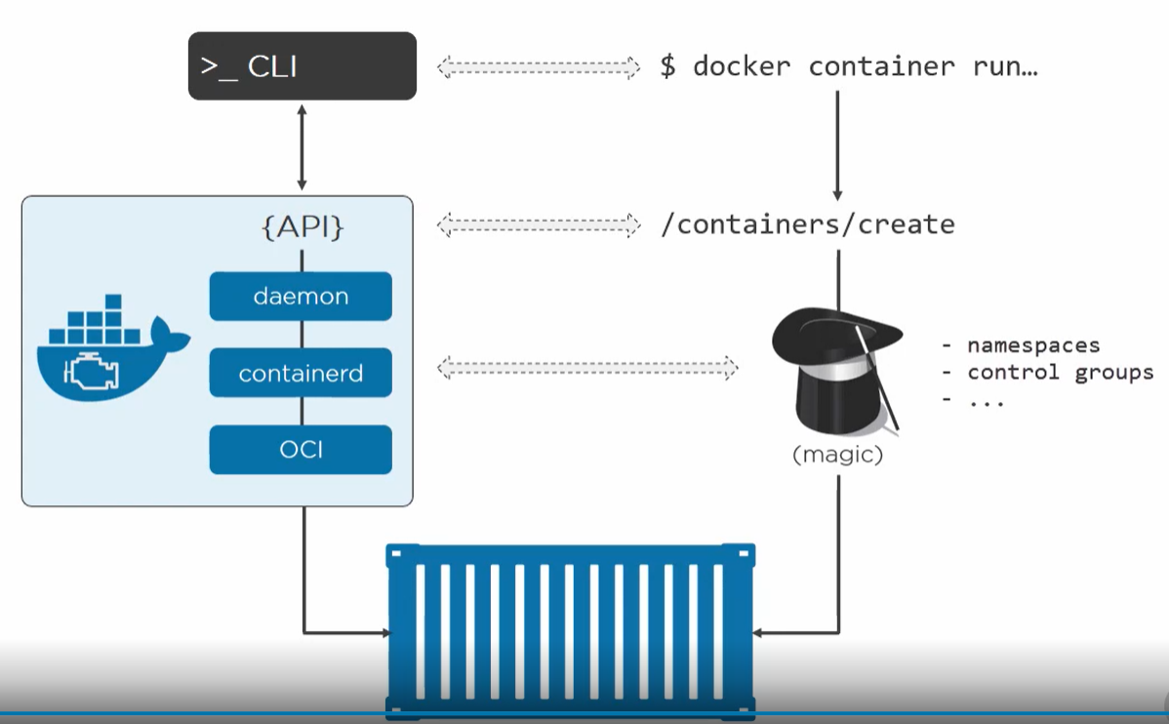

Steps:

* We use the command line to create a container.
* The **client** takes the command and makes appropriate API call to the create container api of the engine.
* The engine pulls all the required kernel stuff and pop a container.

**KERNEL INTERNALS**

Linux containers are there for ages but very specific kernel engineers used namespace and control groups to create containers.

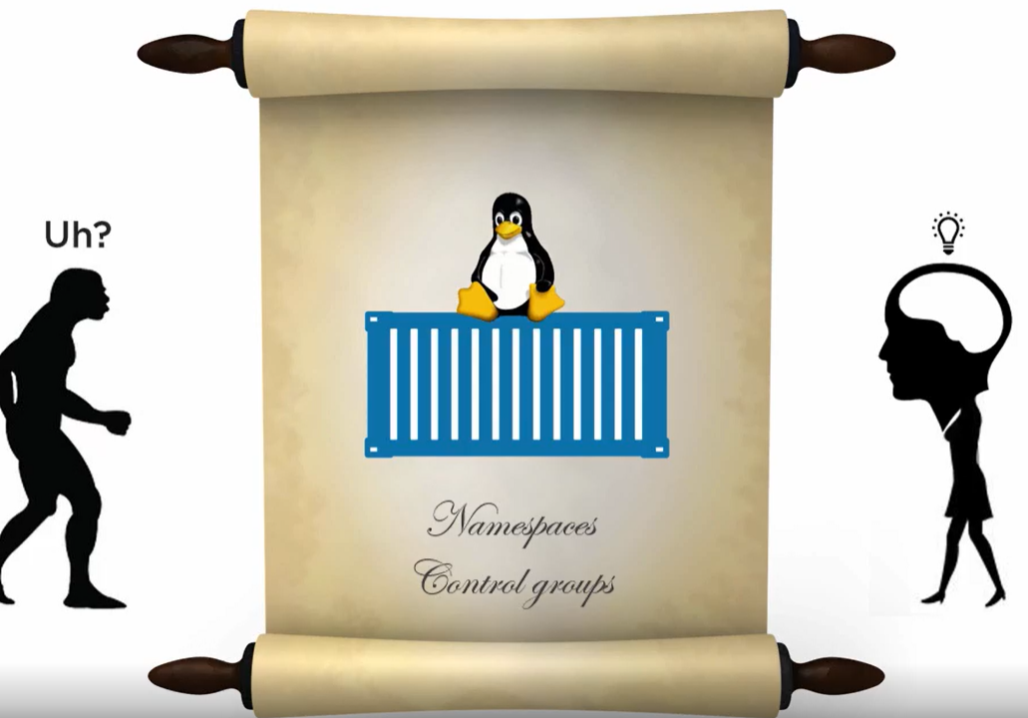

**To make a container we need:**

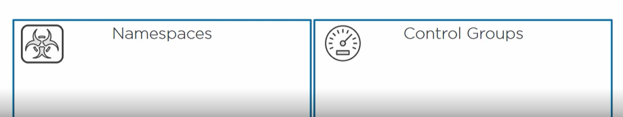

**Namespaces**

It takes an operating system and convert it to multiple isolated virtual OS.

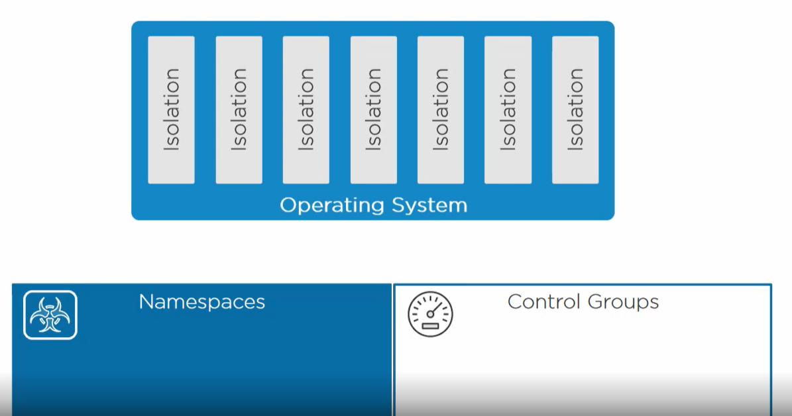

**It is equivalent to hypervisor in VM.**

**In VM world**

* Hypervisor takes a physical machine and converts it into multiple virtual machines (having its own cpu, ram etc) and isolated from each other.
* **Each virtual machine feels like a regular physical machine.**
* **VM shares the single physical resources.**

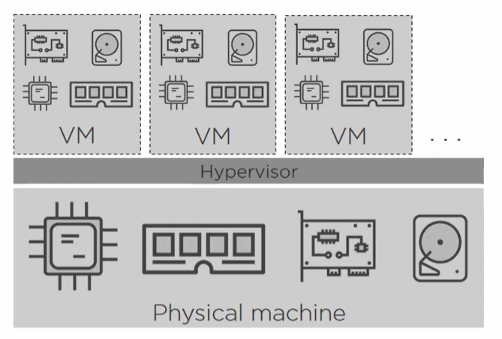

**In container world,**

* Namespace takes a single operating system with its resources(filesystem, process tree, users, pid etc) and carve it into multiple virtual OS (called container).
* Each container has its own root file system, process tree ,own root user etc**.**
* **Each container feels like a regular operating system.**
* Containers shares the single kernel on the host**. Which means containers shares the physical resources of the host.**
* **One container does not know about other containers.**

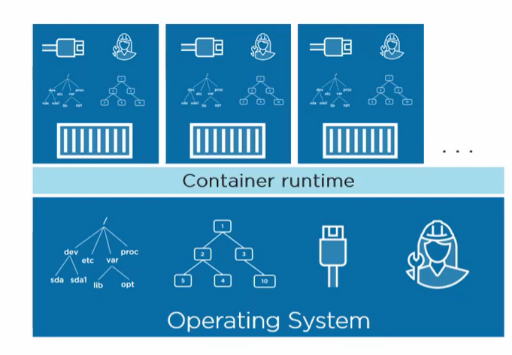

**Linux namespaces**

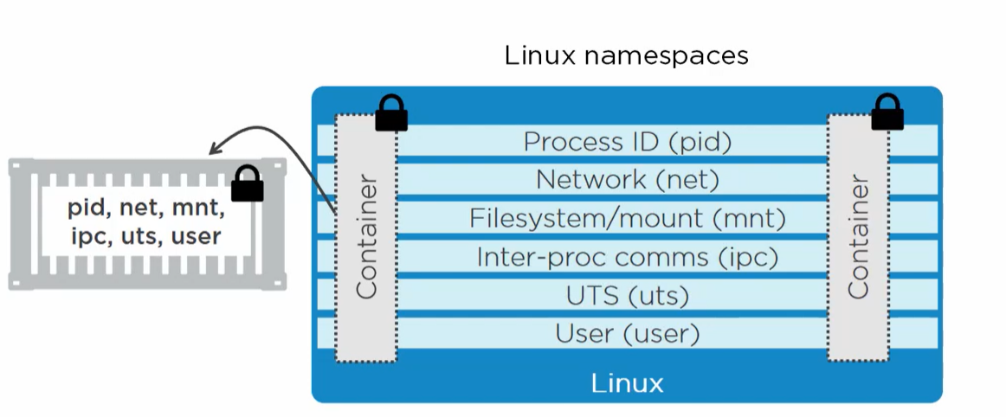

Each container has its own pid, net, users etc and it is locked and secure like a standalone OS.

**Pid –** It gives each container its own isolated process tree. The process in one container is totally unaware about other container process.

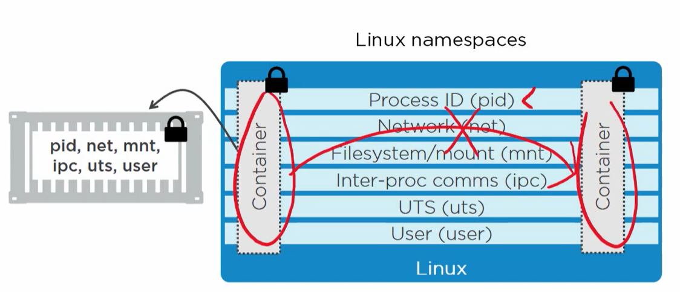

**Net –** It gives each container its own isolated network stack like IPs, routing table etc.

**Mnt –** It gives container its own isolated root file system like /C: in windows.

**Ipc –** It lets processes inside a container to access same shared memory but not outside the container.

**Uts-** It gives containers its own host name.

**User –** It maps the root user of the container to non-privilege user of the host.

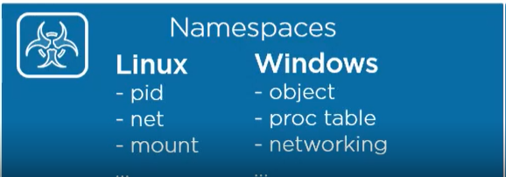

**Control Groups**

In a multi-tenant environment, we don’t want one container utilizes all the system resources. Hence, we want some kind of control to limit the use of resources.

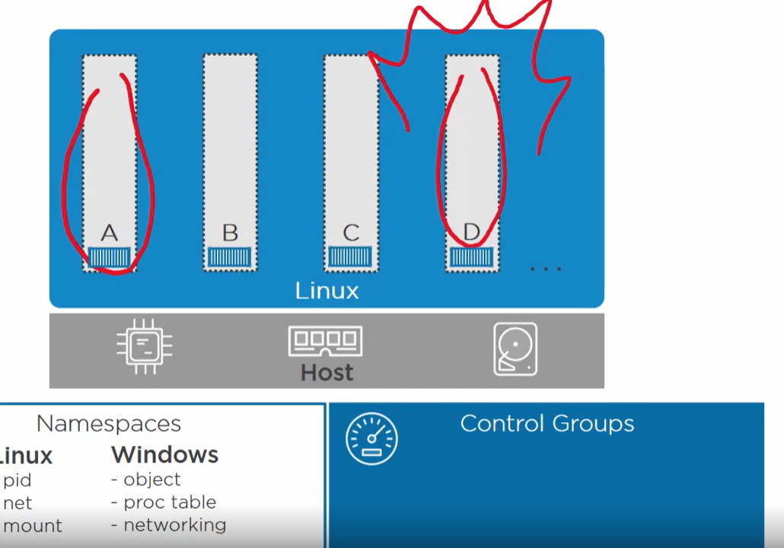

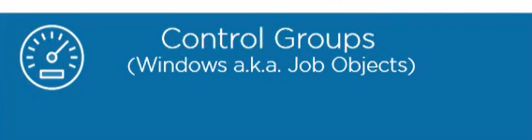

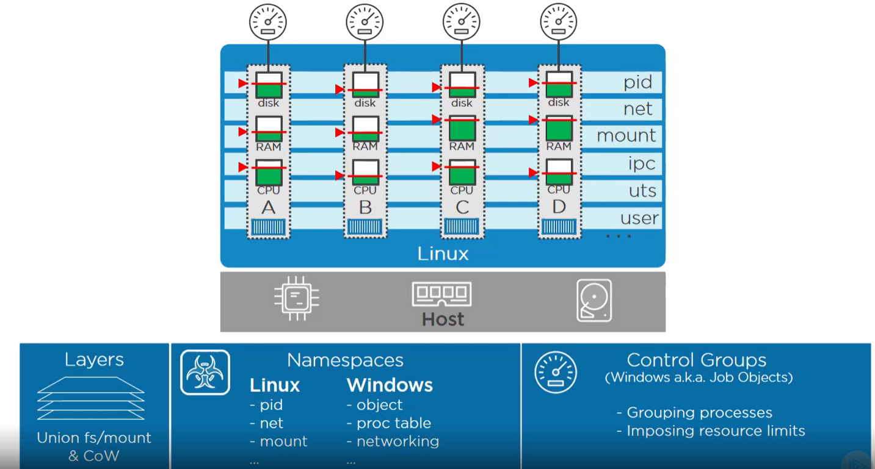



Docker engine is the core of docker and it makes container easy.

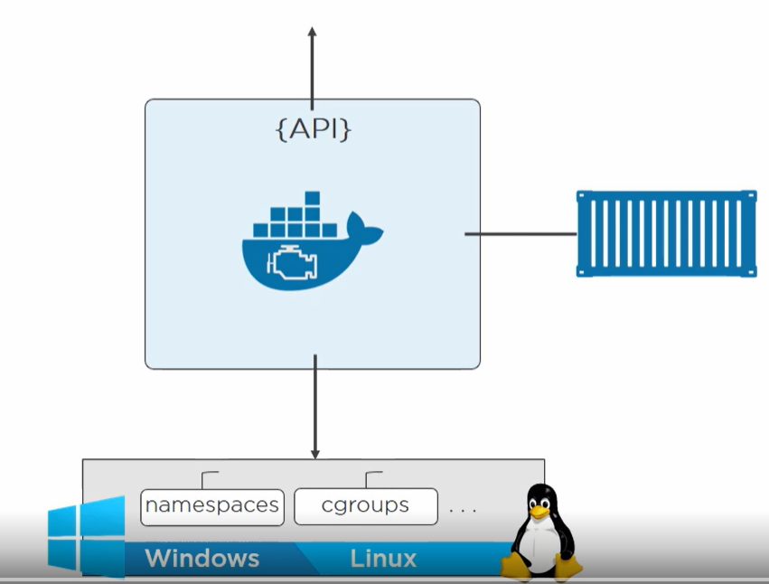

1. It exposes the API for us to write command in CLI and client will call APIs.
2. It interfaces with the kernel stuff and pops up the container.

Docker is a full platform with the core is engine.

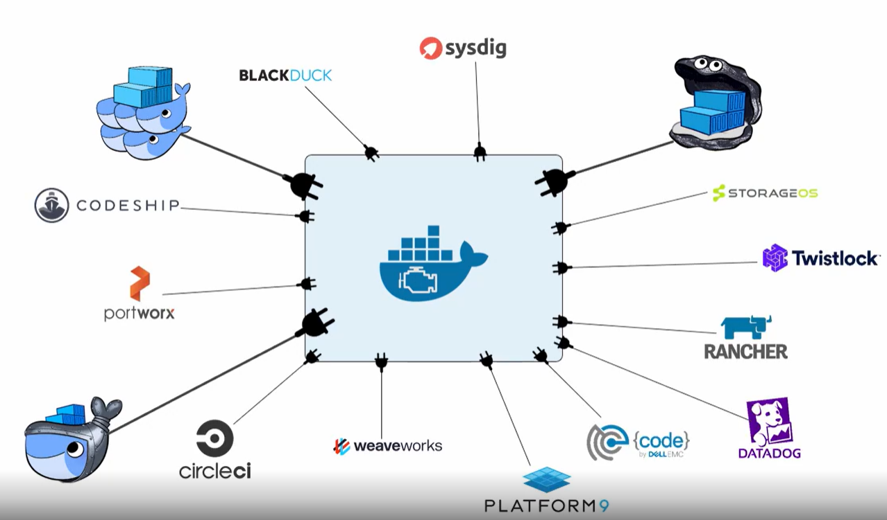

**Docker engine history**

Docker came out from a company called **DotCloud**. It is a python tool called dc.



It is a wrapper for **AUFS** (union file system) and **LXC** (it a bunch of tools which interfaces with kernel stuff).

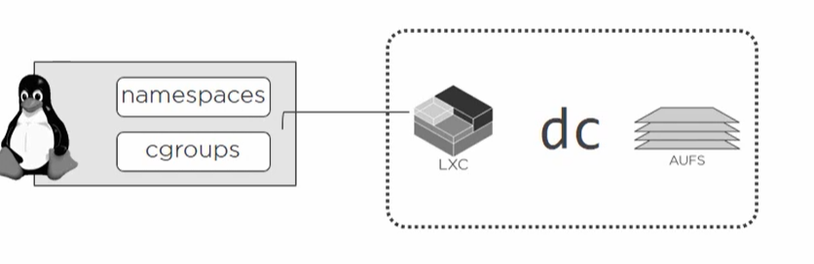

As docker was relying on LXC(external tool) and changes in LXC affected docker. LXC was not in control of docker. Hence, they break up.

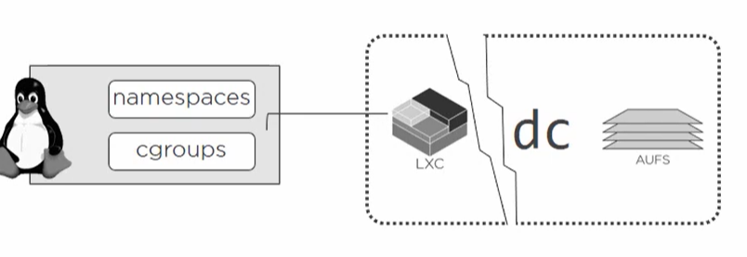

Docker wanted something like LXC but with its control.

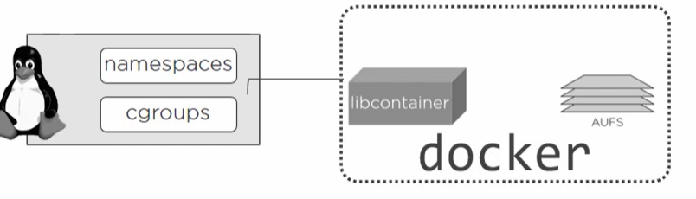

Hence, libcontainer came and its under docker control.

But soon docker became monolithic instead of being fast it became slow.

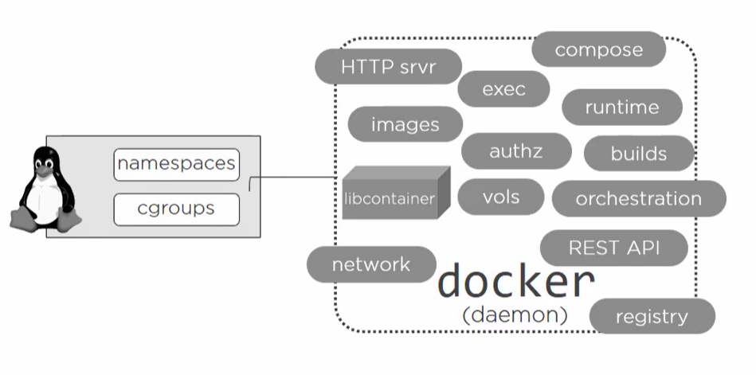

So, it was not favorable for the ecosystem ex: Kubernetes was using docker for containers but docker has its own orchestration tool which is contradicting.

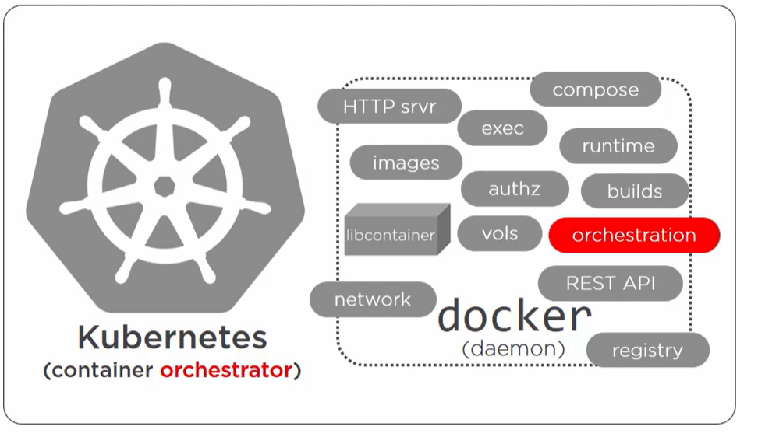

Hence there was a demand to refactor things in docker. At the same time of refactoring open container initiative started which was standardizing few things.

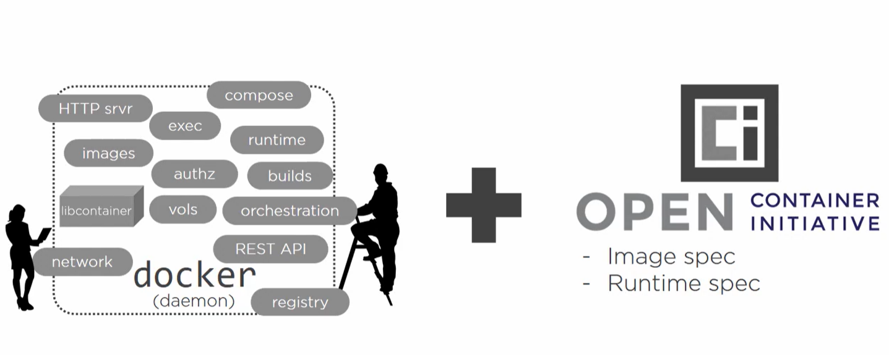

Today

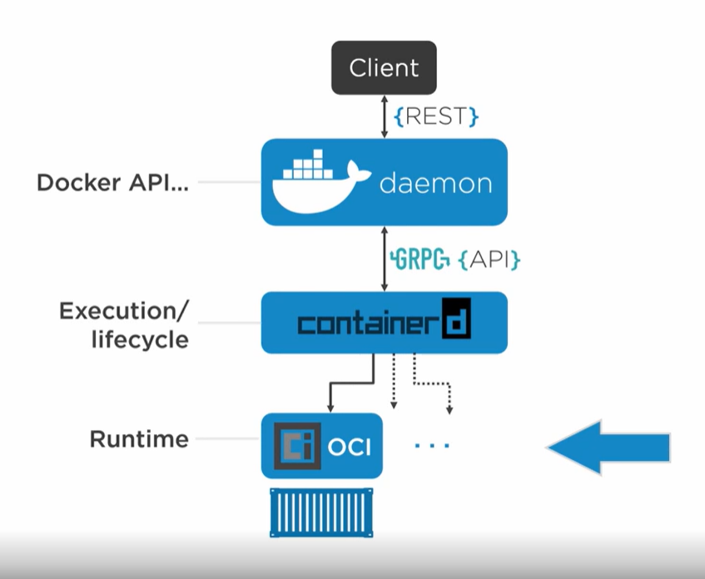

* We have client in which we write our command and it takes the call to daemon.
* Daemon is the place where all Docker API written.
* **Container d** it controls the execution and lifecycle start stop of the container.
* OCI it interfaces with kernel to create container.

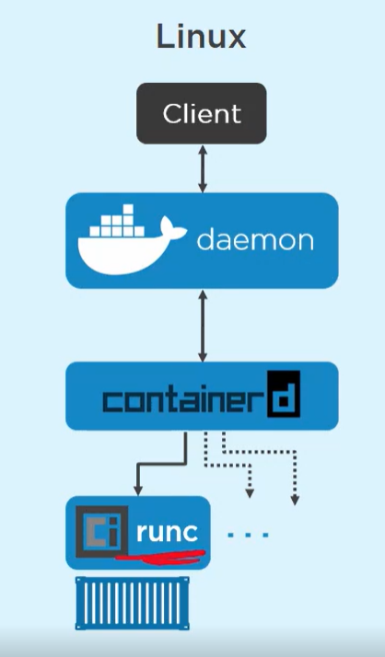

Runc is the runtime reference of OCI.

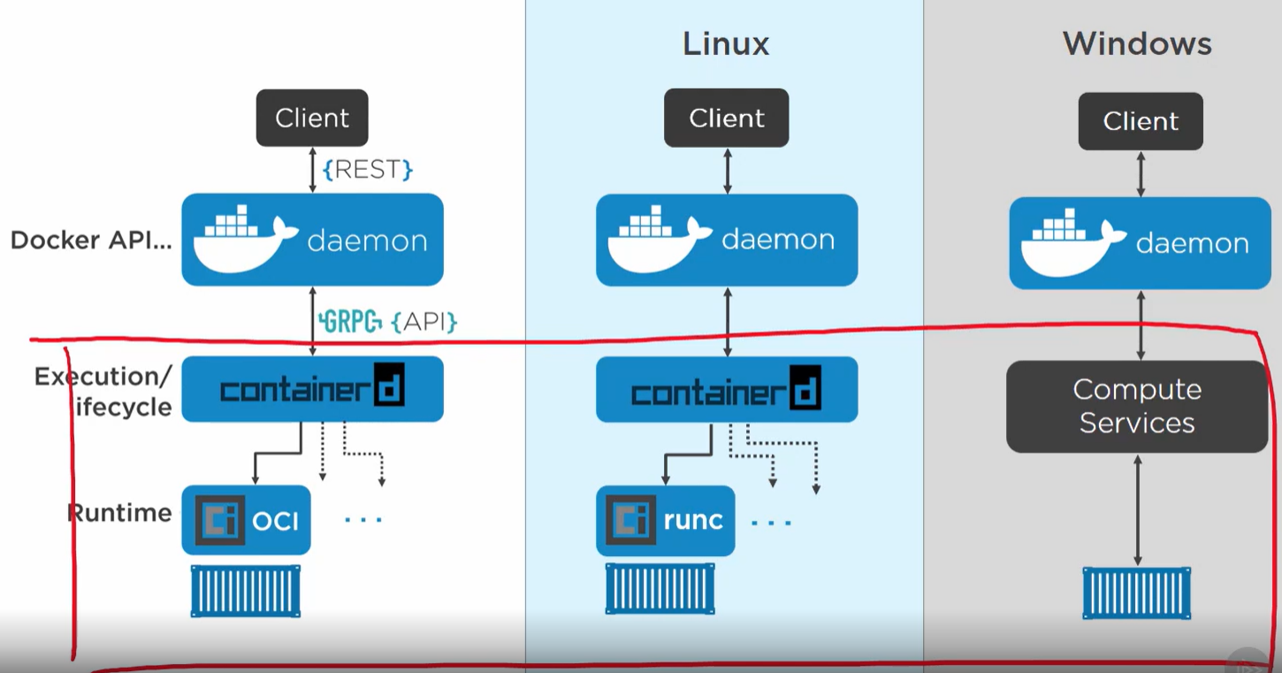

The API stuff in windows and linux is same only the low level architecture is different which users doesn’t care about.

**Container creation flow**

1. To create a container, we execute a command on CLI and client takes the command and post it to the end point of API in **deamon**.
2. Deamon is not aware about how to create a container.
3. Deamon calls the **container d** over GRPC api on local unix socket. But container d also can’t create a container.

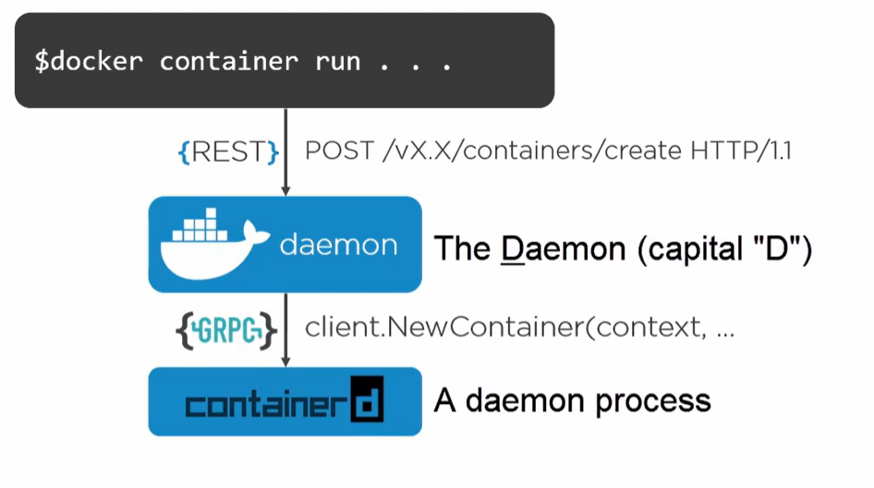

1. Container d starts a **shim** process for every container.
2. **Runc** then creates a container and exits. Runc is called for every new container but it exits after that.

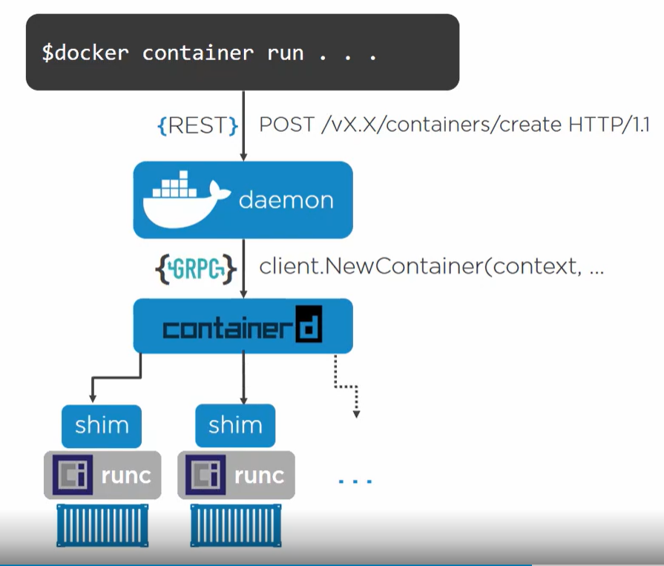

A container runtime **shim** is a piece of software that resides in between a container manager (containerd, cri-o, podman) and a container runtime (runc, crun) solving the integration problem of these counterparts.

**Benefit of decoupling of container** creation process from deamon is even we restart the deamon it will not affect running containers. We can upgrade and restart the daemon and it will automatically reconnects with the shim of container.

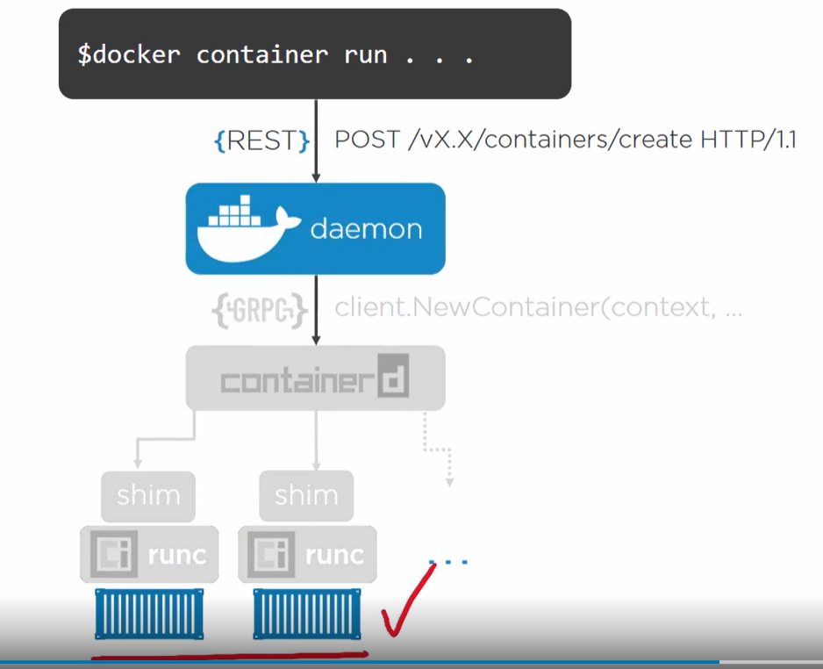

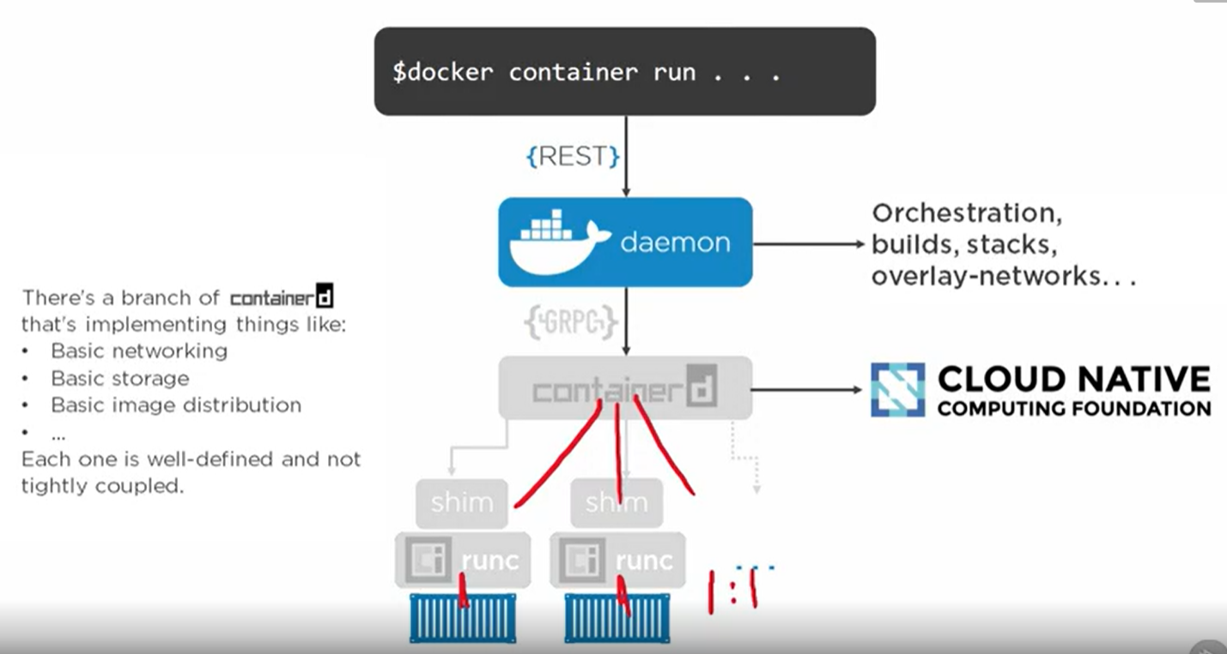

Runc and container has 1:1 mapping but container d and runc has 1:many relation. 1 container d process can create multiple container.

**WINDOWS CONTAINER**

**Native windows container** that runs only windows apps.

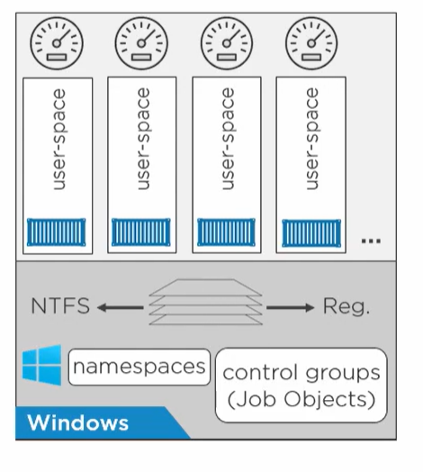

Everything is similar to linux container. They also have **NTFS** and **Reg** which helps in image layering like AUFS and overlays in linux. Union file system with a write privilege is integral part of docker.

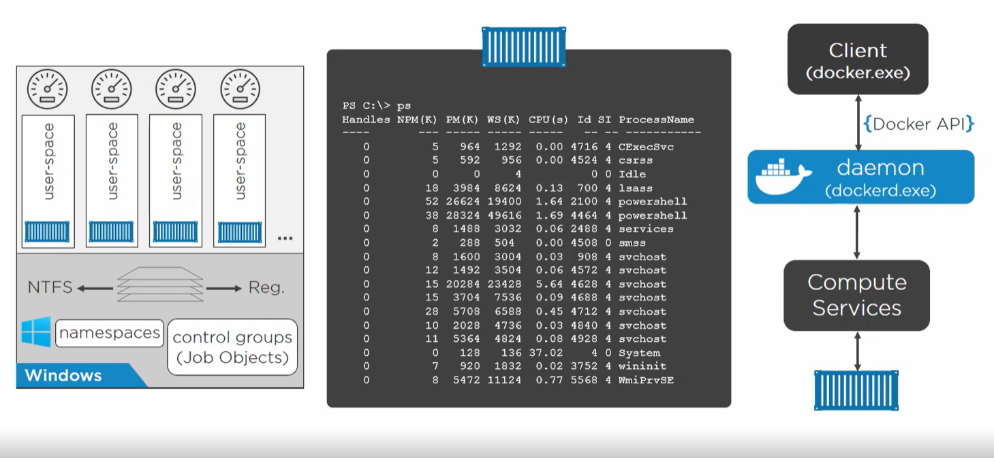

In linux we have 1 process per container but in windows we have some dependent process. First process is smss process.

**Hyper V containers**

**In hyper V containers we can run both windows and linux containers.**

If we have an app which requires a **linux kernel** or **different windows version kernel** hence we use hyper V container.

When we run a hyper-v container then windows runs a lightweight VM which runs an isolated linux/windows kernel OS.

So, a hyper-v container has its own virtual OS and it doesn’t uses its host OS kernel .

For linux container on windows host OS it makes sense to use hyper V as linux container needs a linux kernel for isolation.

Why windows container also run on hyper-v because virtual windows OS isolation is better than namespace isolation.

**1 container per VM? how**

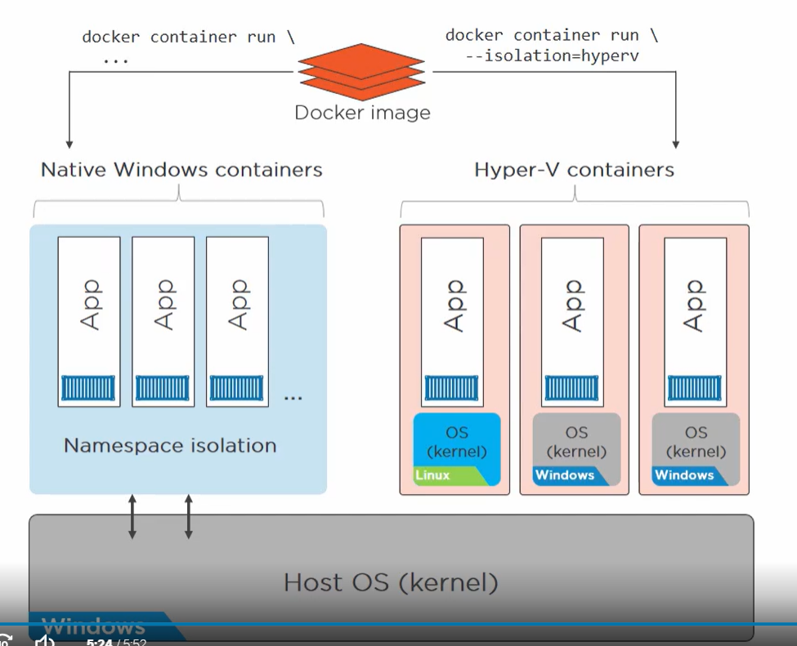

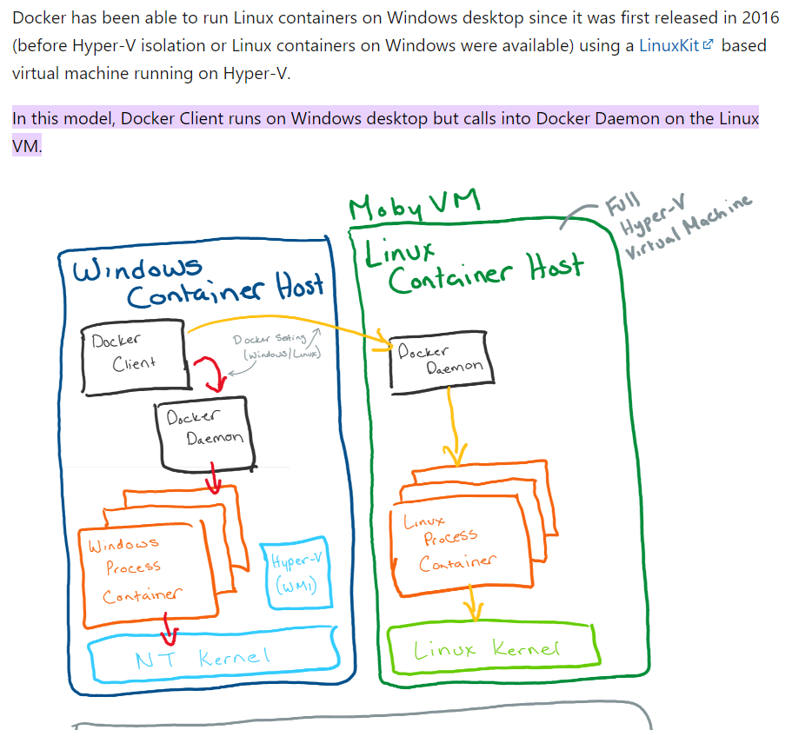

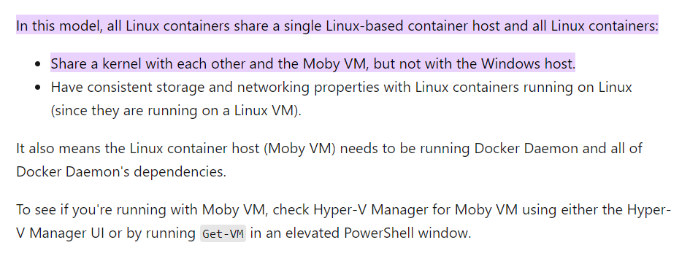

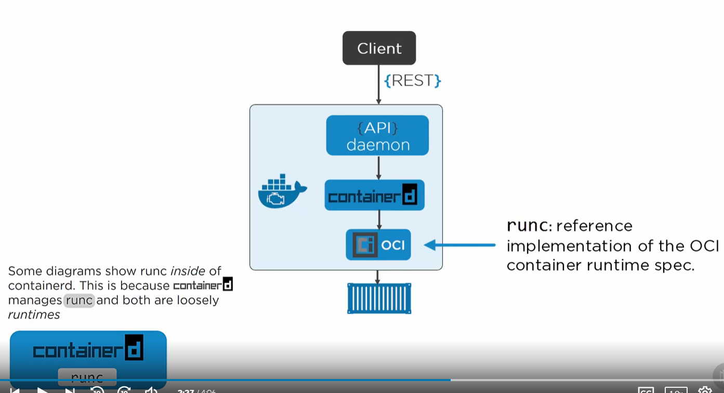

**IMAGES**

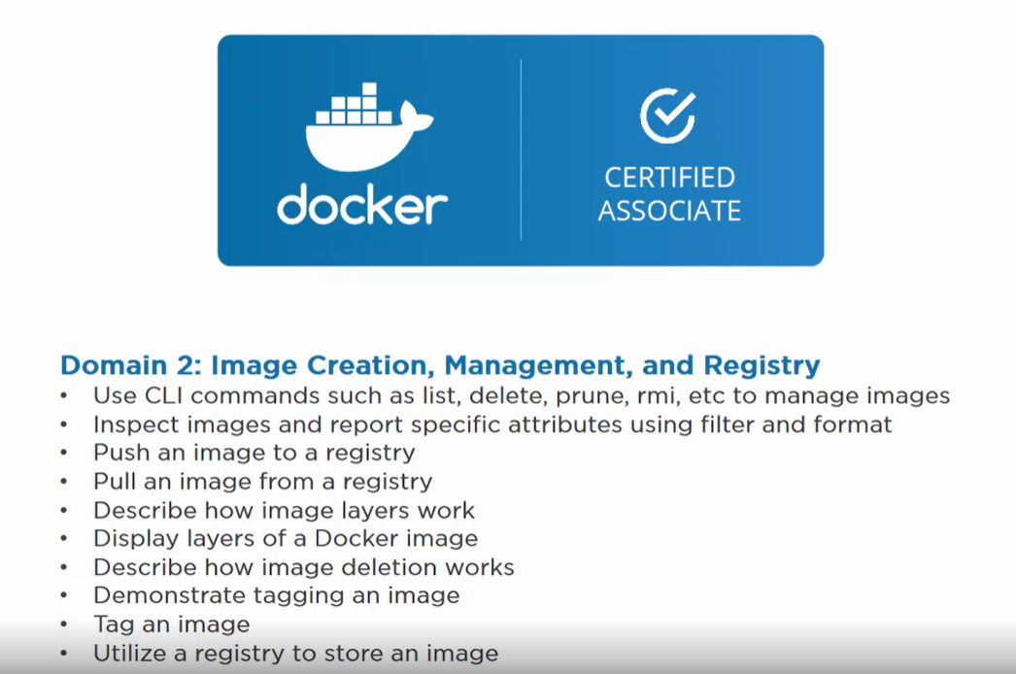

* **Images are read only template to create a runtime container**. It contains layers of files and objects and we stack them using storage drivers.
* It contains all the code and dependency required for application.
* Bunch of files and manifest.
* OS and app files are files required to run application.
* Manifest are json file describes how all fits together.

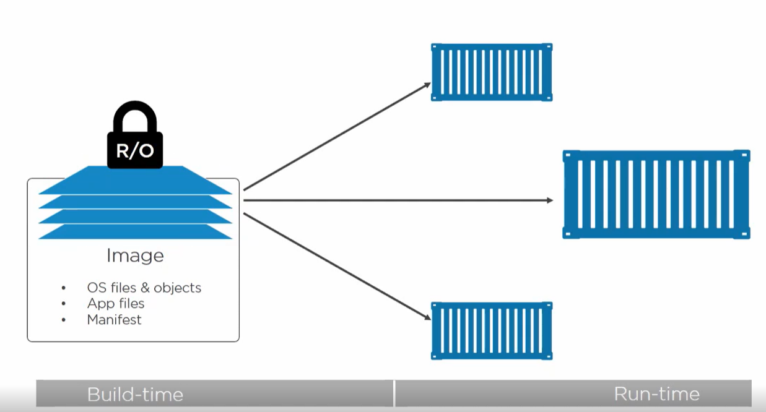

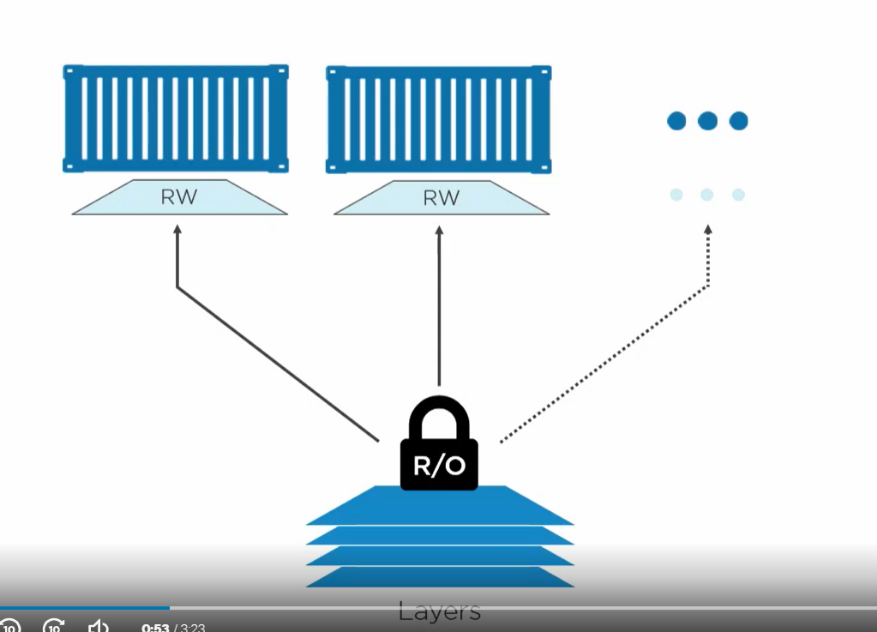

* We create multiple containers using an image with each having its own writable layer.
* No point any data in layers of image changes.
* If container wants to change any data in layer it basically copies the image and makes changes in RW container layer.

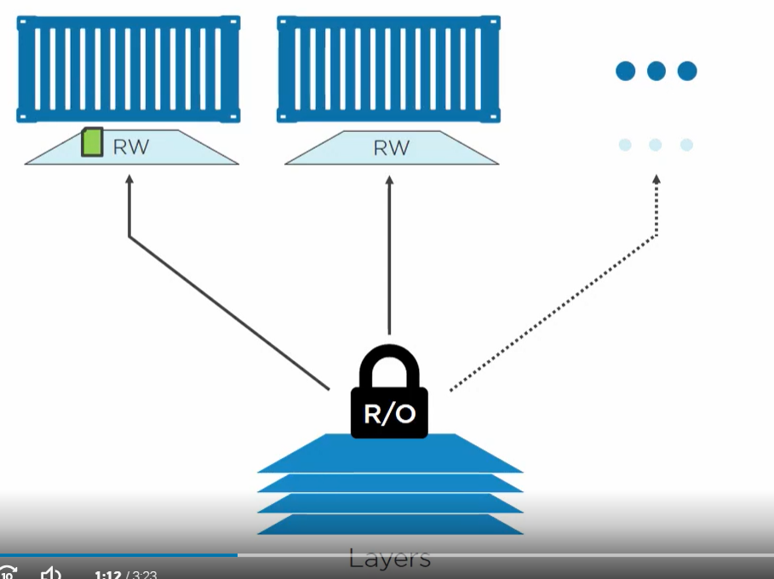

**Docker pull images**

* It pulls the images from dockerhub.
* It first looks for the **manifest file** (The file will have details about all layers. Each layer is an independent layer and not aware of each other and are stacked together.)
* Images are not a single blob but a bunch of independent layers loosely coupled by a manifest file.

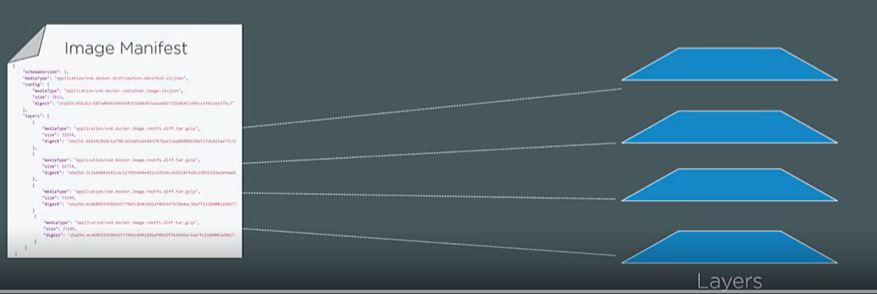

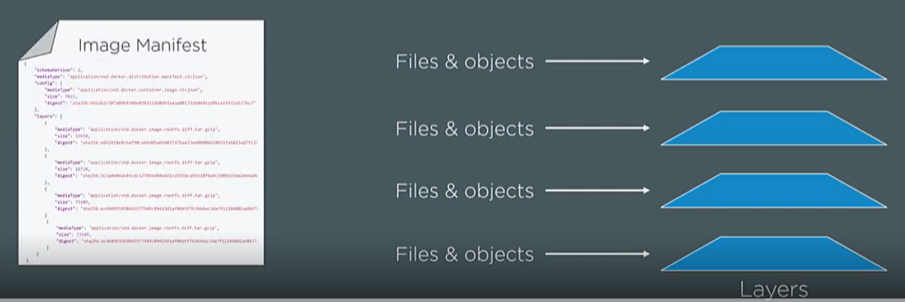

Manifest files describes the images when it is created etc and it also contains details of layers and how to stack them.

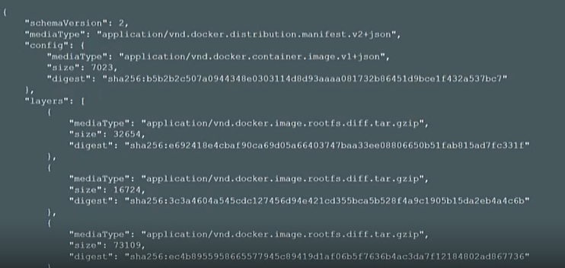

**When we do a pull we are not pulling a single blob rather we pull bunch of layers.**

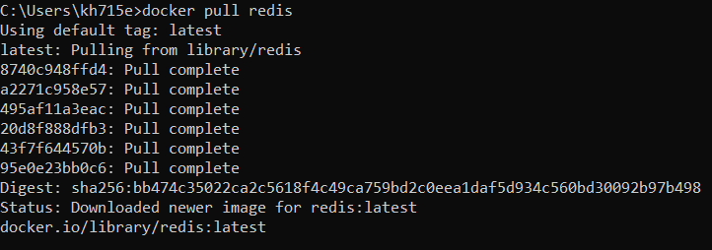

**Docker pull command has 2 step process.**

1. Get the manifest
2. Pull the layers.

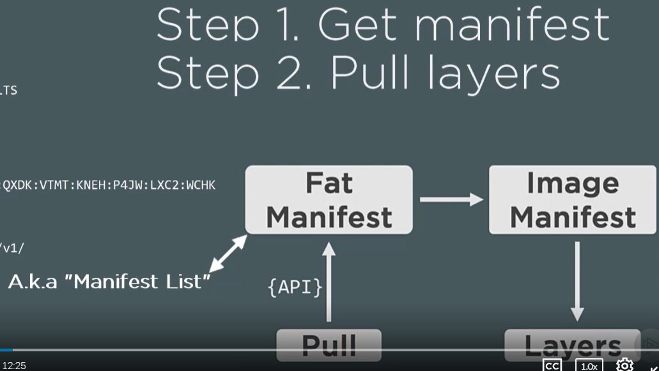

After it get image manifest then it downloads independent layers from blob store.

**Hashing Images**

How we will get to know image we got is what we wanted?

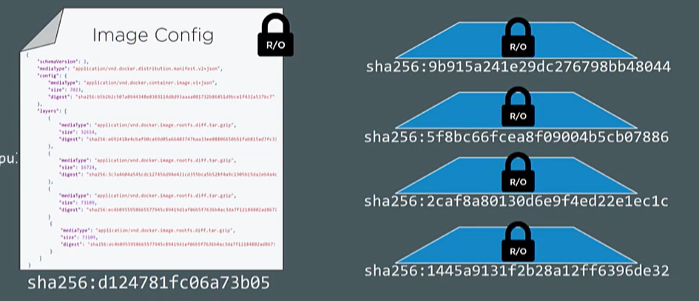

Manifest contains the hash of each layer. We request the storage to give us layer with a particular hash and once we got that we match the hash of the layer with what in manifest.

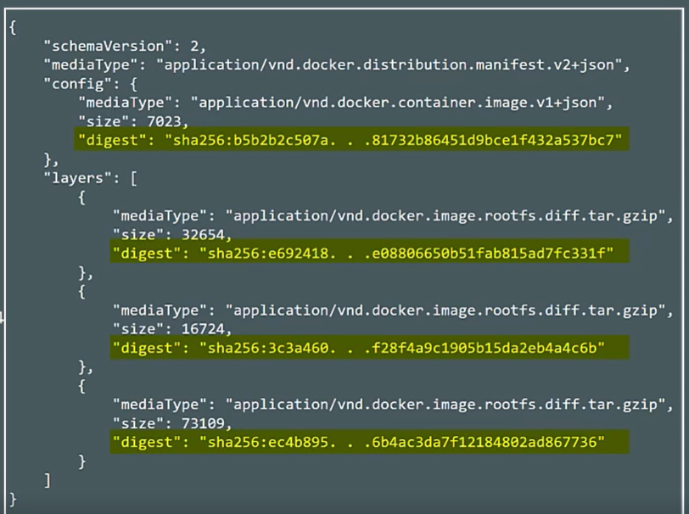

Once downloaded where these images getting stored in local.

**Linux container on linux kernel we have storage in /var/lib/docker/overlay2/….**

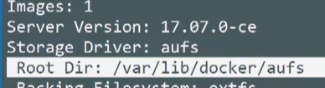

**Windows**

Windows container is stored in C:/programdata/docker

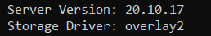

Whenever we delete the image it will delete all the layers

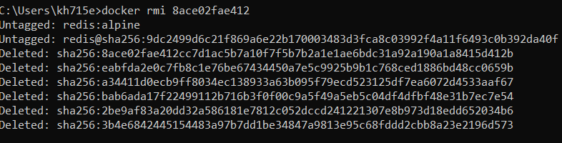

**Base layer is a operating system layer whenever we run the container it uses the OS of the kernel in base layer.**

Even if we are running our container on windows OS then also the file system feels like running on ubuntu.

<https://linuxhint.com/create_docker_image_from_scratch/>

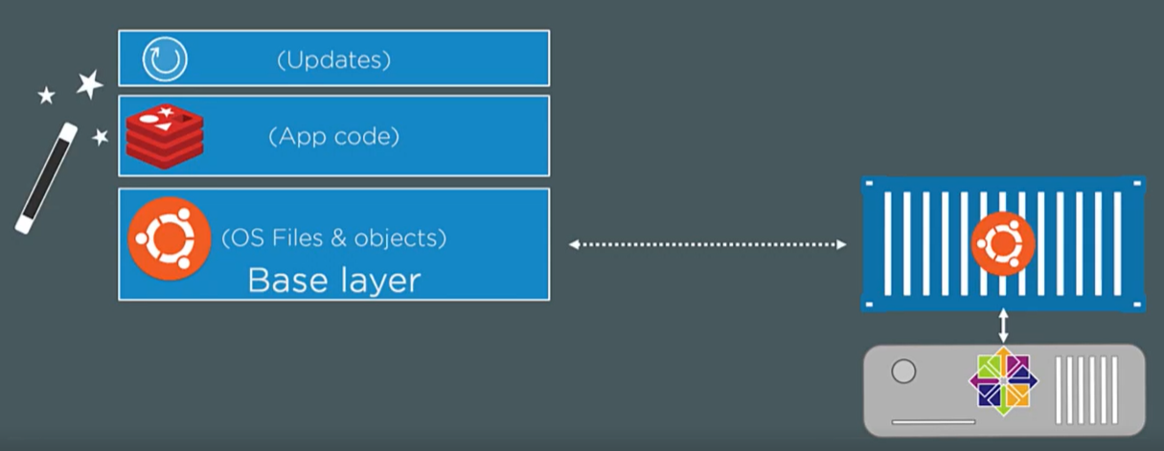

**We see this as single unified filesystem with the help of storage driver according to instruction in manifest.**

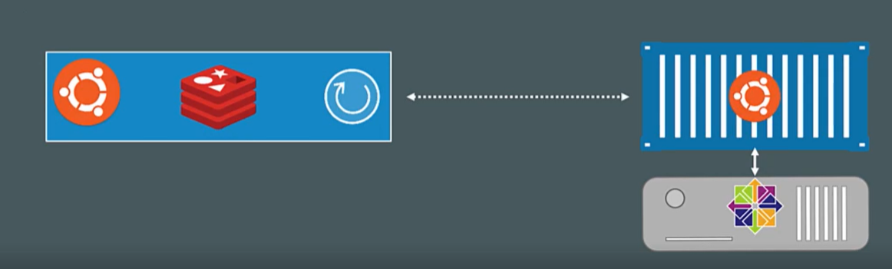

In docker desktop we can change to windows container to see the location of images.

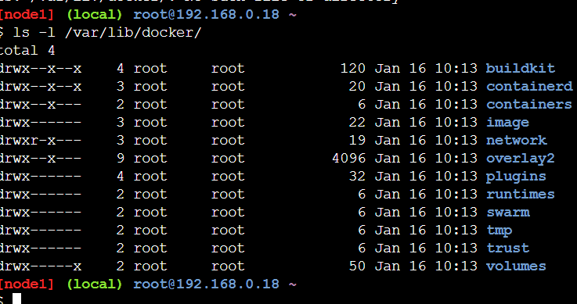

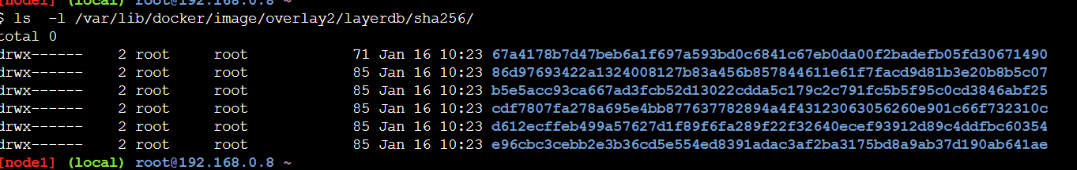

**No easy way to match the layer id with their directory on the host.**

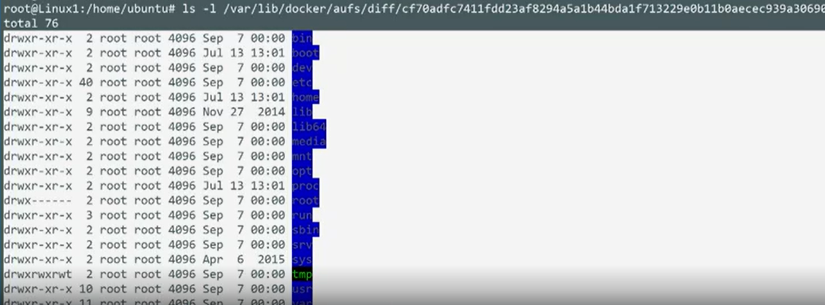

Above is the content of the base layer of redis image.

**Docker history imageName**

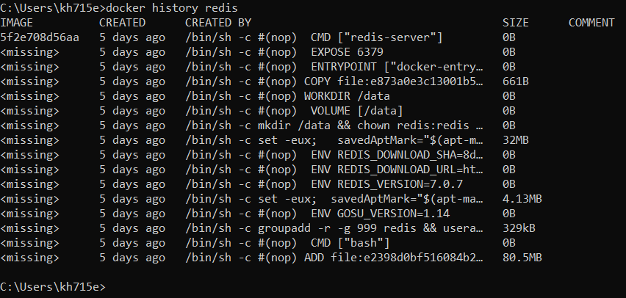

All non-zero values are creating a layer.

**REGISTRIES**

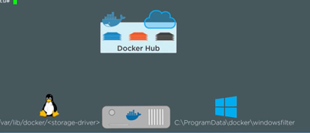

We pull images from **docker hub**. Google, Microsoft has its own registry. Whenever we pull image from registry it gets stored in local drives.

**Pulling windows container from docker hub**:

docker pull mcr.microsoft.com/dotnet/samples:dotnetapp

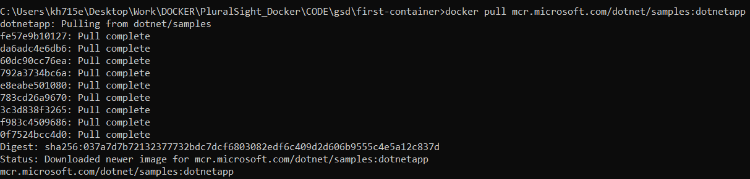

We see 9 layers are getting pulled and stored in our local **C:\ProgramData\Docker\windowsfilter**

**Image Name conditions**

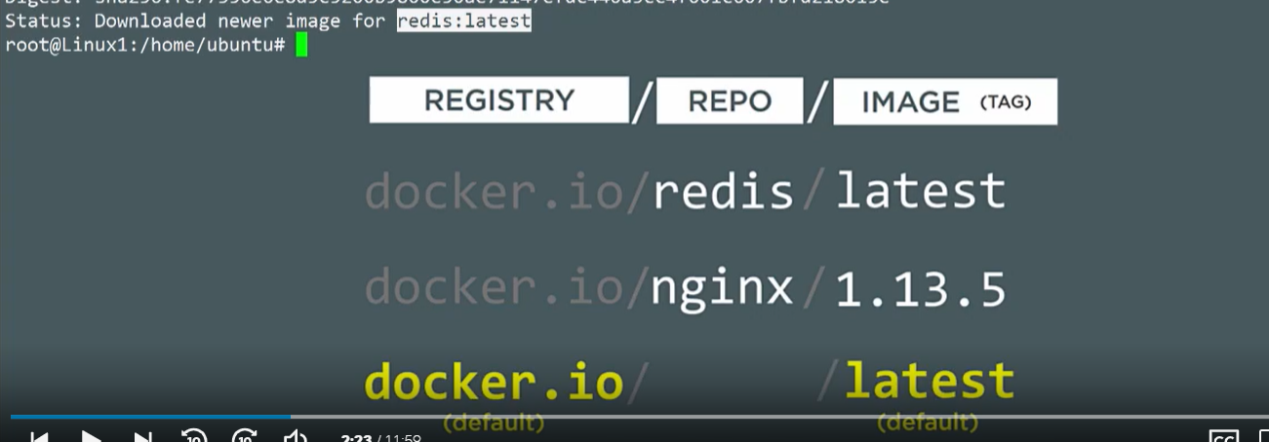

3 parts **registry+repo+image**(tag)

When we do **docker pull redis**

By default it takes from docker.io (dockerhub) and it pulls **redis:latest** image.

**HASHING/DIGEST and Registry pull push**

When we push or pull an image it is not a single blob but a layers of files that are loosely coupled using a manifest file.

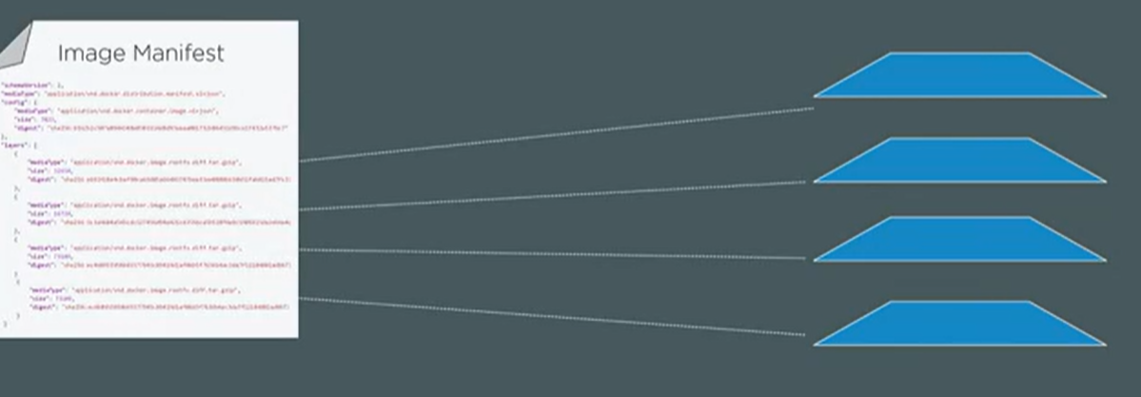

* Each layer on a host machine is having its own hash called **content hash**.

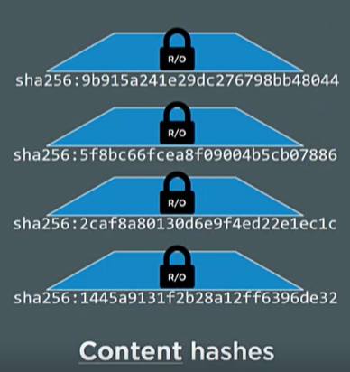

* But when we push or pull the image we create a manifest file and have all layer id in it.
* When we push it we need to compress these layers and hashes changes, hence the hashes of layer does not match with manifest hash id.
* Hence when we push we change the hash id in the manifest and we call it **distribution hash.**

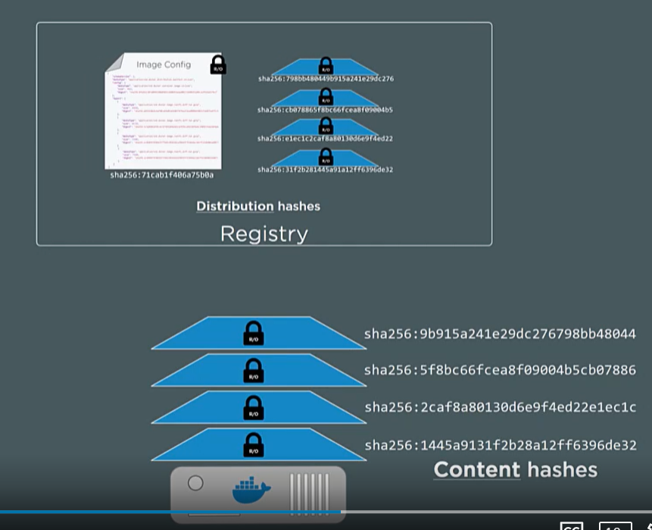

When layers are stored in storage then it is stored with random hashes.

So apparently when we are pushing and pulling we can hash **3 different hash id** for a layer.

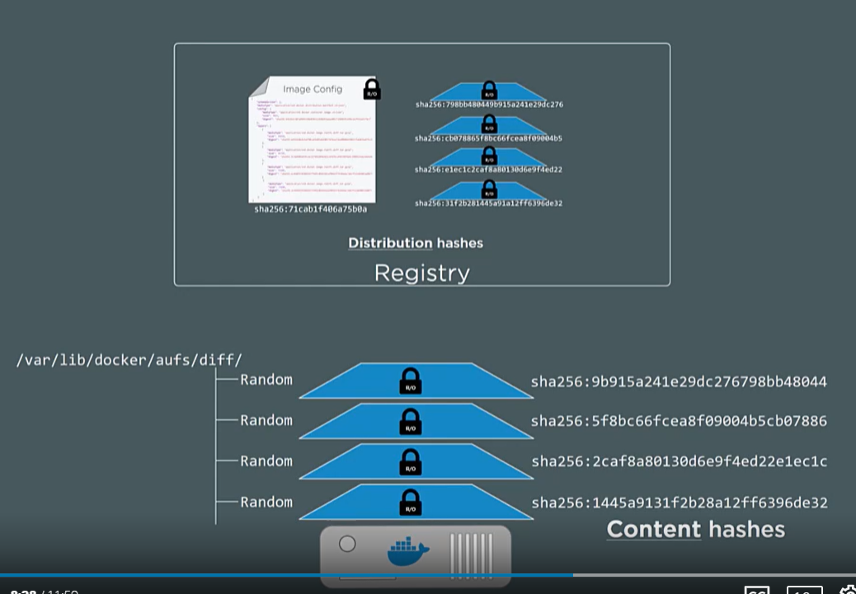

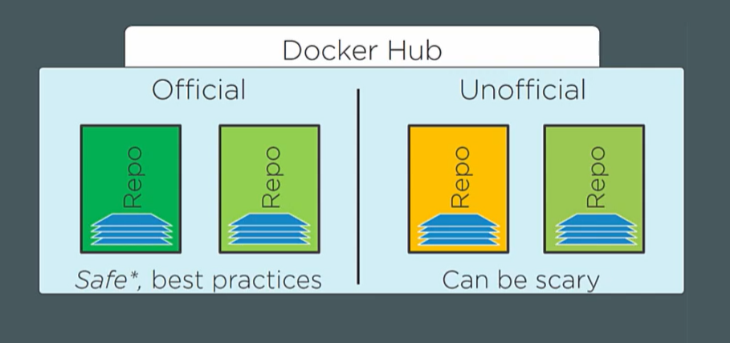

Images are stored as repo on a registry.

**Best practices for image**

1. Use official images.
2. Keep your image size small.
3. What if official image doesn’t have what we need in our image. We take an official image like alpine and build on top of it.
4. Don’t use latest in production use versions.

**DOCKERFILE**

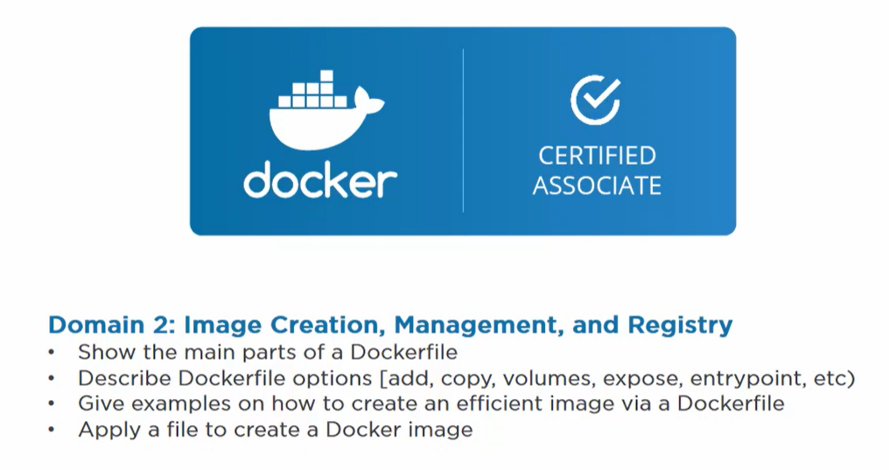

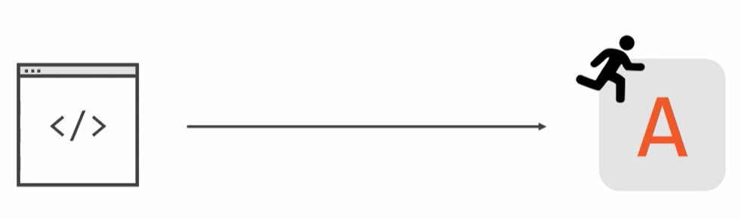

**Starts with an app code Ends with a running app**

We have our code to put it inside our image we create a Dockerfile. **List of instructions on how to build an image with code and other dependency inside.**

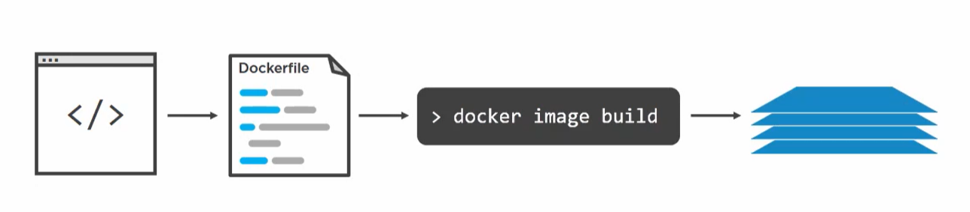

**Steps**

1. We have some application code

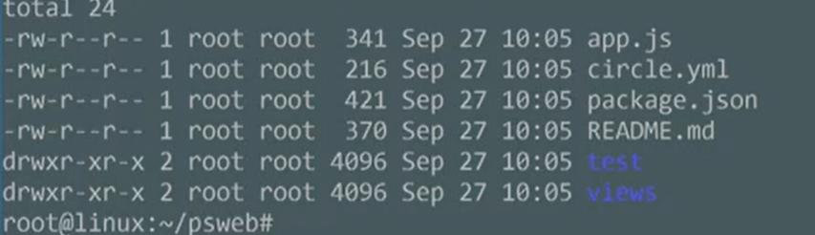

1. We create a docker file in the root directory of our application code. **Dockerfile**

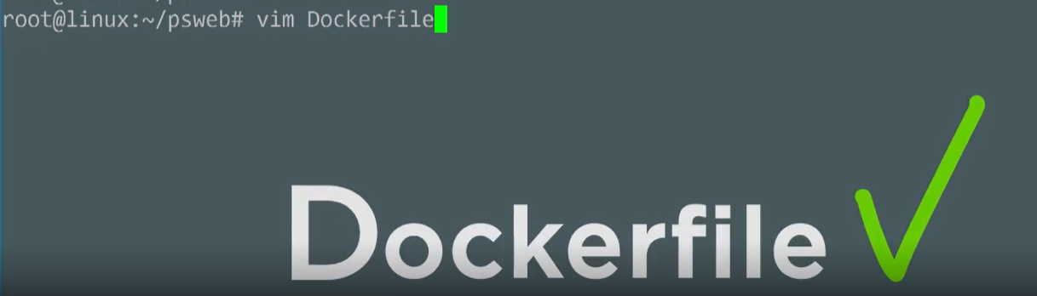

1. Note dockerfile is a list of instructions use to create image with app code inside it. We describe our application to dev or operations using this file.
2. **Base image**- our application is linux based so we need some kind of base image with linux. **FROM alpine (base linux image)**

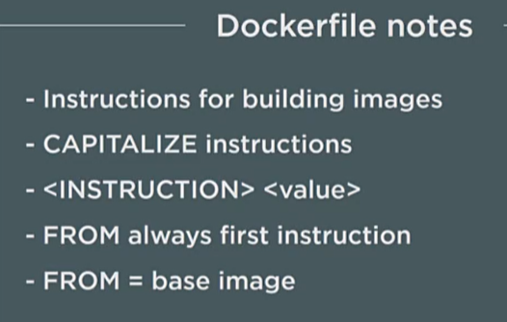

FROM alpine

FROM = instruction

Alpine =value

1. Good practice to label maintainer

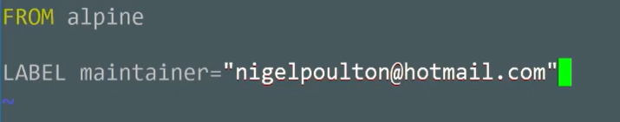

1. App we are using is a node app so use a command to install npm and node. It lets us run command and build activities inside image. **It creates a new layer.** We are adding some software to the image and we get a new layer.

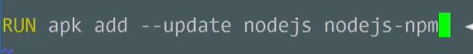

1. Copying our source code from base to /src inside image. Creating one more layer.



1. Using metadata WORKDIR /src
2. Now we are running npm install to install all dependencies. Adding new layer.

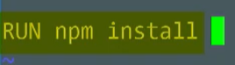

1. App listens to port 8080 so EXPOSE 8080
2. Last we run our app 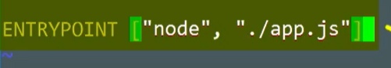

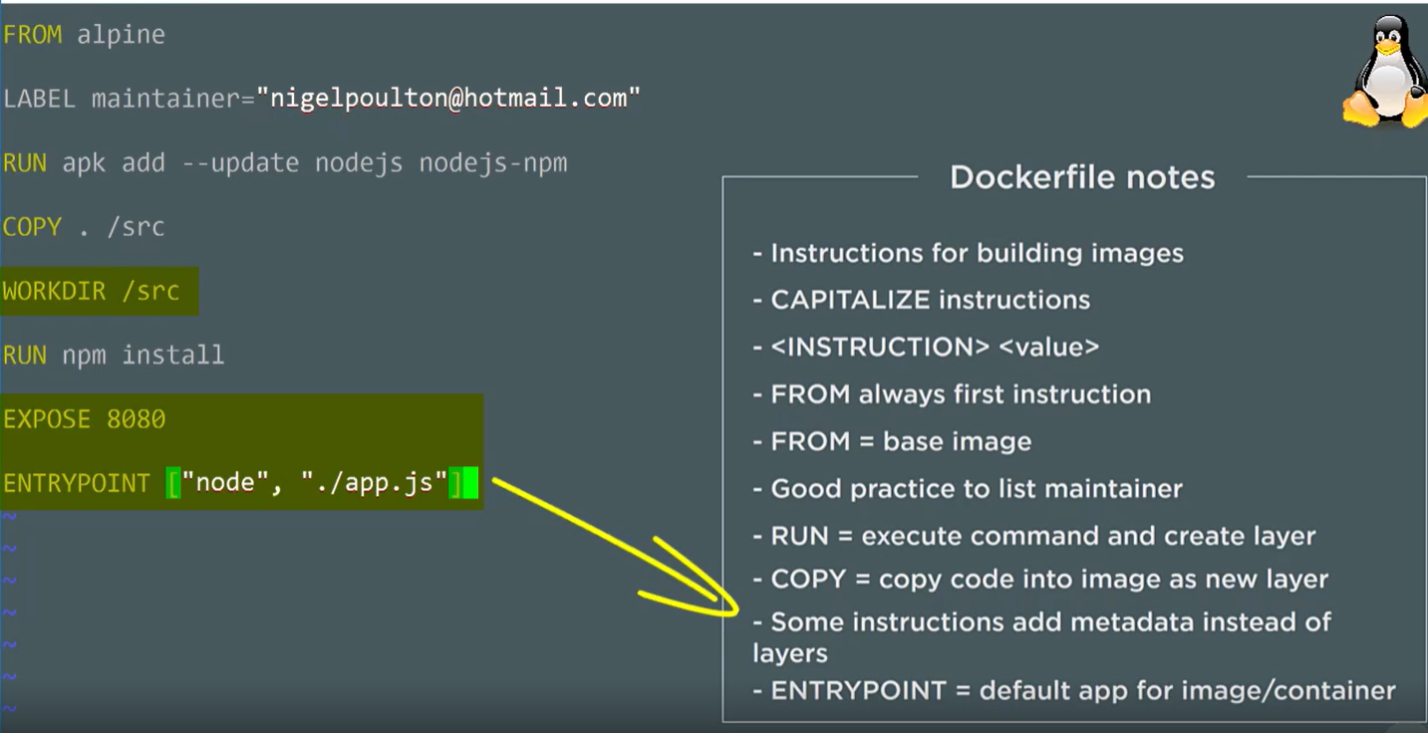

We have an app with 4 layers.

1. FROM alpine
2. RUN apk add
3. COPY ./src
4. RUN npm install

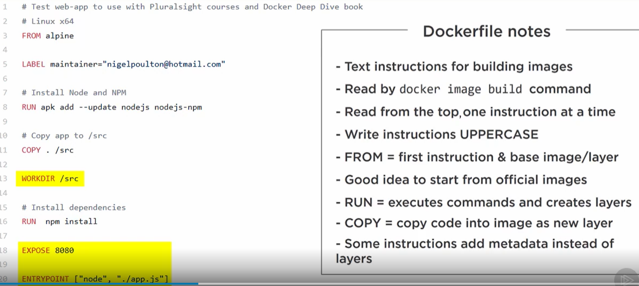

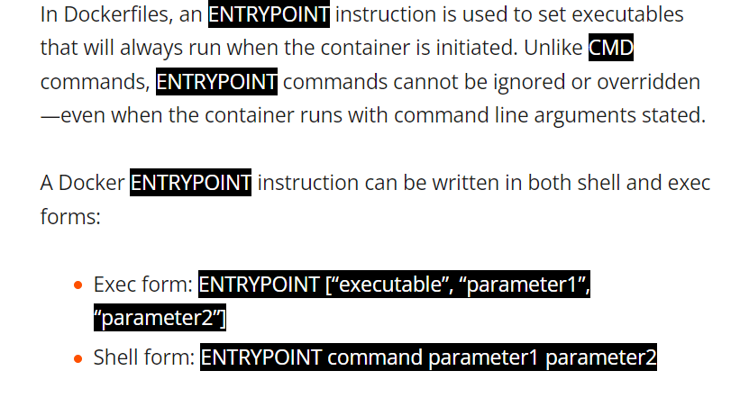

**Build context** – Location of our source code. Dockerfile is located in the build context.

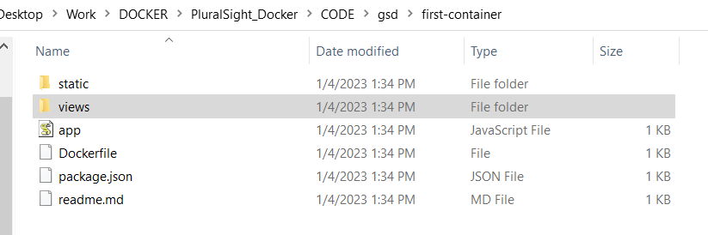

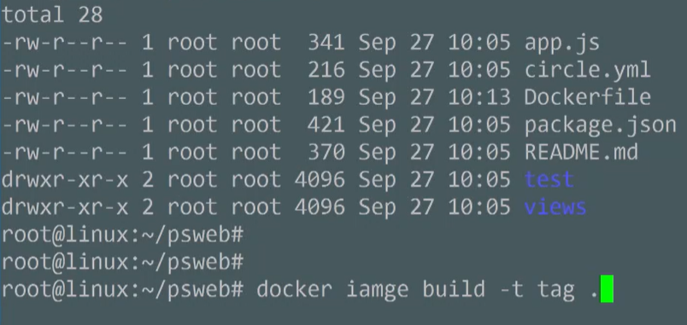

In the command we put . cause we are in same location as build context.

When we do build everything in the build context is send to deamon even the nested file in context.

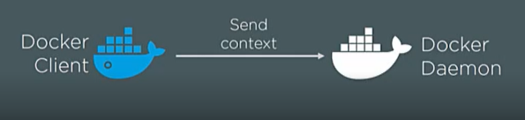

**Our build context can be our remote repo as well**

**Docker build -t imgaename /https://gitrepo**

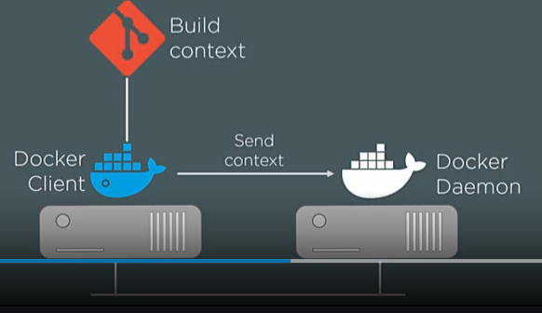



It now starts to stack the layers one by one

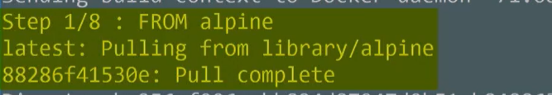



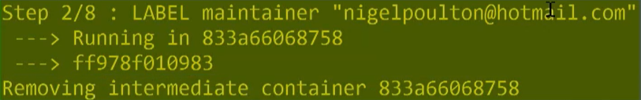

For this layer docker runs a temporary container and creates the layer and container gets deleted.

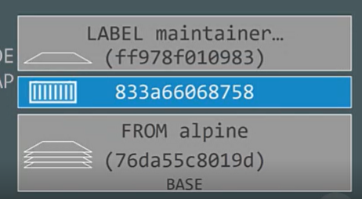

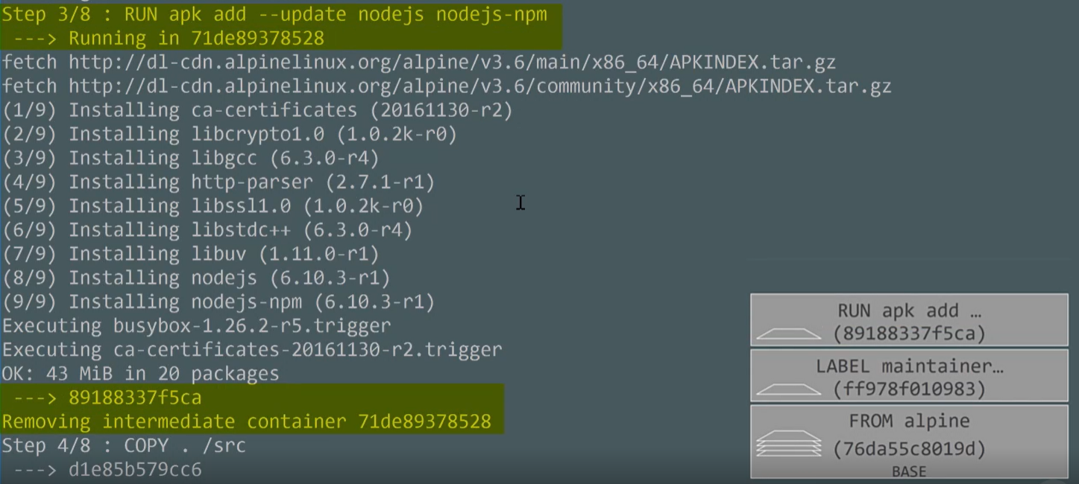

Again it creates the container and then when layer is created it losses that container.

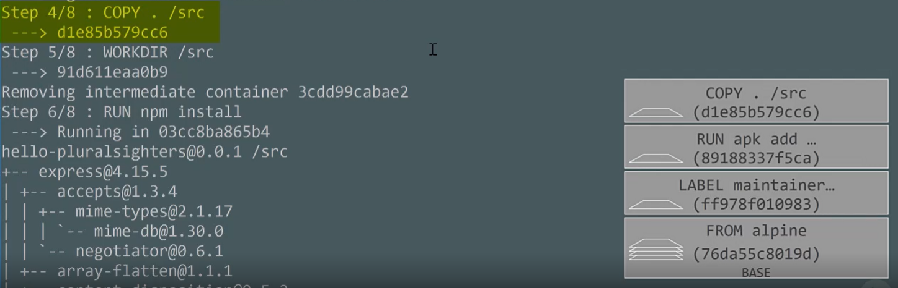

Final layers

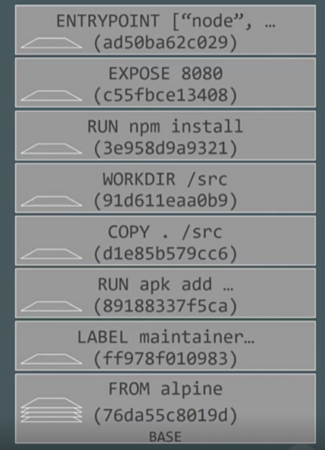

But in actual only the layers which contain data stays rest gets deleted.

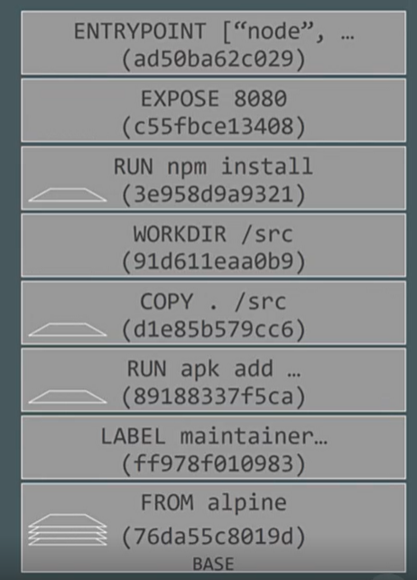

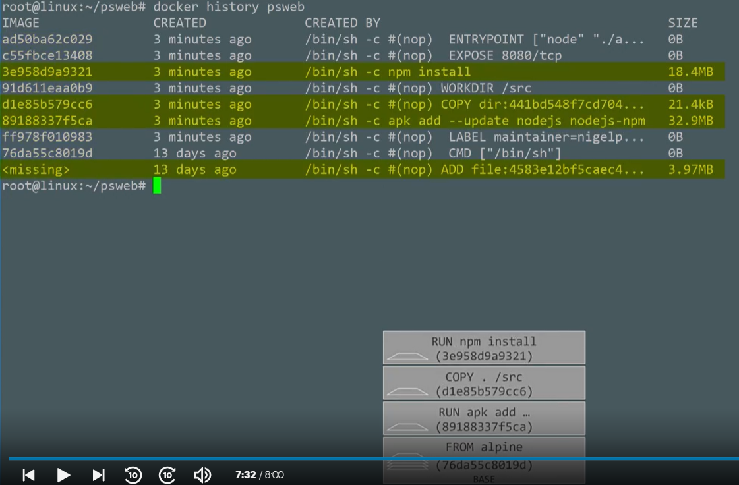

When we do **docker inspect image** we see 4 layers there.

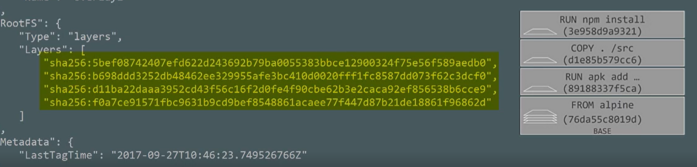

The ids don’t match cause the layer in storage is random and layer id from pull is distribution hash.

**Multi-stage Images**

Our image should be **smaller** in size and use less OS resources.

Smaller images will do faster build, deployment, less money wasted for storage, less vulnerable.

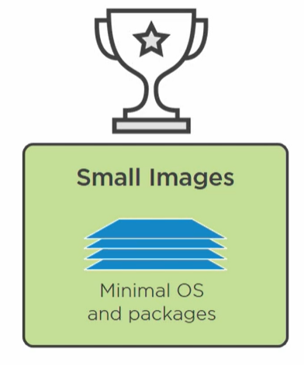

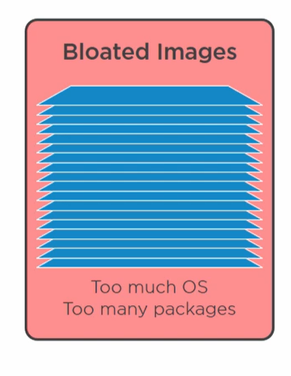

We have big base image on top of it we layer with some build tool and finally we ship this big image to production with all the build tools. But why production image needs layers require just for build?

Its just like we are building a car with all machines and robots in a factory and then ship the car with factory attached.

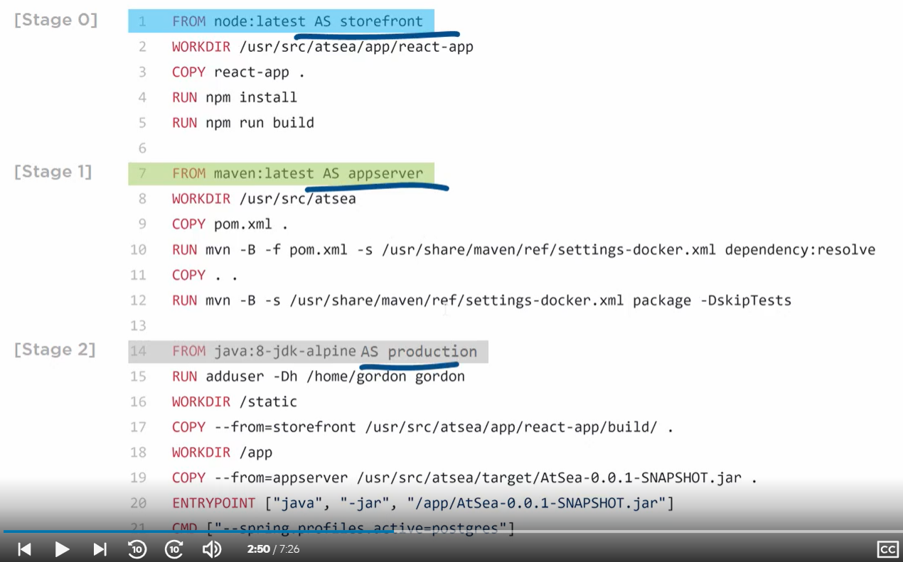

We have a docker file with 3 stages. When we do a docker build it will go from top to bottom.

1. It pulls a big node image1.
2. It adds on bunch of layer on top of it and creates even bigger image2.
3. At stage 1 it pulls another big base image 3
4. Does bunch of stuff and adds more layer to image 3 and creates image 4.
5. But in stage 2 we don’t need these big images rather we need just the tiny output of both images.

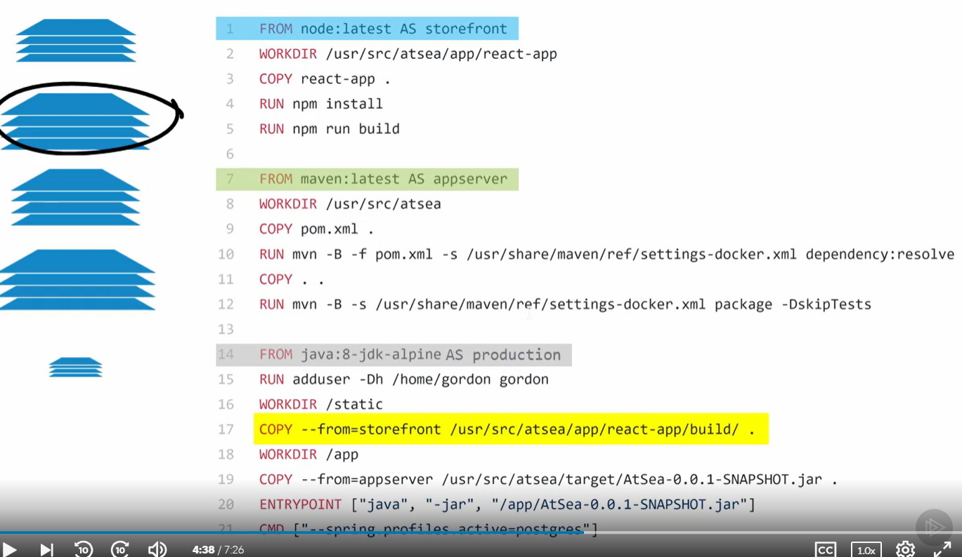

1. In stage 2 a comparatively small base alpine image is taken and **copy from** command grabs the image 2 and it picks just the final war/ear we want and leaves rest image behind.

Once we do docker build -t multistage .

We get 5 images

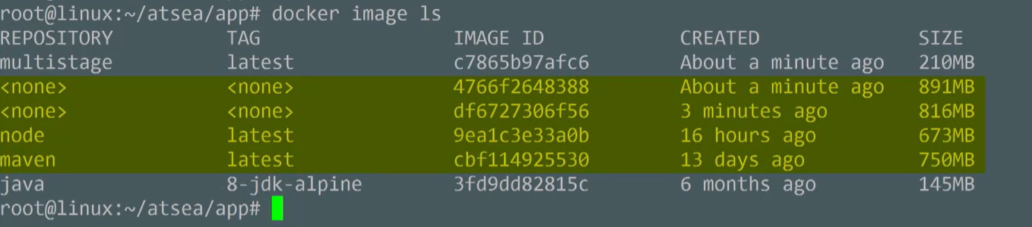

But one we need in production is multistage which is smaller size.